**Worked Confirmed Window**

# Geoff Anderson G3NPA and Aki Yoshida JA1NLX

## 1.0 GENERAL

The Worked/Confirmed window is designed to show a summary of the Band/Mode combinations worked for a specific prefix. Additionally, it will show specific summary information for the callsign entered in the Logbook Entry window, if that callsign has been entered into the log previously. Some elements of the way this information is displayed are configurable by the user.

An empty window is shown here:

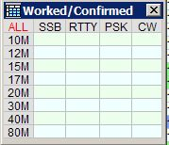

WCW_1

The bands and modes displayed are derived from your BandPlan and whether you have the Stats column marked with a "Y". The more bands and modes you have so marked, the larger will be the table shown above.

To drag/drop Worked/Confirmed Window columns, right click on the Worked/Confirmed Window. Click on menu option. See details in the paragraph 4.0.

The table becomes active as soon as a recognized prefix is entered into the "Call" edit box of the Logbook Entry window. The table will remain blank if the particular country has not been logged before, but if the prefix has been recorded previously, then the appropriate Band/Mode combinations will be activated, as shown in the example below.

**Note**: The Worked/Confirmed window title bar will change and include that of the prefix entered, the Operator and the type of QSLs to be included for confirmations (see below)

**Note**: The current Band/Mode cell is indicated by the boarder with clear line. (See 40M CW below)

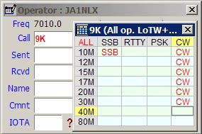

WCW_2

## 2.0  WORKED/CONFIRMED WINDOW MENU

A right mouse click with the cursor anywhere on the Worked/Confirmed window will produce the following set of menu options:

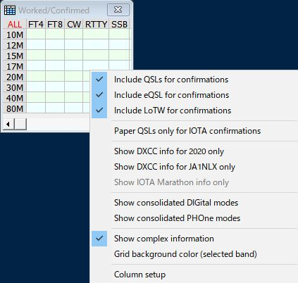

new WCW_3

### 2.1 Include QSL/eQSL/LotW for Confirmations

This menu item allows the user to select what QSO confirmed information is displayed. This will also affect the colors displayed in the DX Spots window.

An example showing the changes that can be observed when selecting different "Include for confirmation" options.

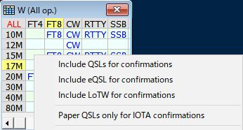

new WCW_13

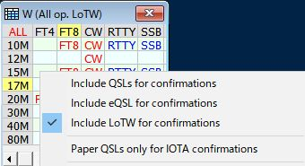

new WCW_13A

### 2.2 Paper QSL's for IOTA Confirmations

This menu item has an effect on the highlight colours in the DX Spots window rather than the Worked/Confirmed table.

As an example If a specific IOTA group has been worked and a confirmation for that QSO is been made via LotW then the QSO will be highlighted as needing a paper confirmation.

### 2.3 Show DXCC for [year] Only

Selecting this menu item will cause the Worked/Confirmed table and the DX Spots window to display information based on the QSOs recorded within the current year rather than the whole log book. The year is derived from the computer system time/date and therefore will update automatically on the 1st January each year. When selected, the upper left hand cell in the table will change from ALL to the current year.

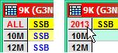

WCW_14

This configuration allows the user to track DXCC performance by calendar year. This status will be based on the current logbook in use and operator selection. When this line is checked, the DXCC status for the current year will be reflected in the Logger32 Child windows listed below:

* + Worked Confirmed Window (including Generic QSOs Window);
  + DXCC Award Window (including Generic QSOs Window);
  + DXCC Challenge Window (including Generic QSOs Window);
  + DX Spots Window (including QSOB4 column);
  + DX Activity window; and,
  + Bandmap Windows.

Panel number 2 of the Upper Status bar reflects the status of the callsign in the Log Entry window.

### 2.4 Show Info for [current operator] Only

The Worked/Confirmed table can display the status for the whole log and all operators or just for the current operator. Logger32 displays this status in the title bar of the Worked/Confirmed Table and the Previously Worked Table as shown below.

In addition the title bar also displays the "Include QSLs for confirmations" options selected. In the examples below all the QSL options have been selected.

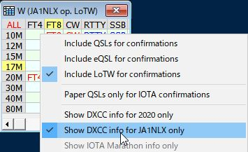

new WCW_4

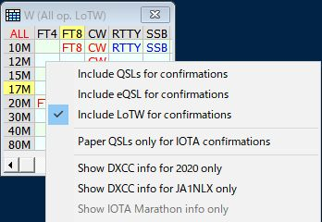

new WCW_5

### 2.5 Show Consolidated DIGital/PHOne Modes

For those users who might prefer to display the consolidated details for phone and or digital modes this may be achieved by selecting the appropriate menu options as shown above. The screen shot below shows the effect of selecting both options. This table uses the mode definitions as set up in the Logger32 Main menu Tools | Database maintenance | Setup phone/digital modes menu item.

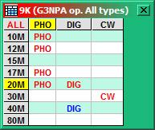

WCW_6

### 2.6 Show Complex Information

The data in the Worked/Confirmed window can be selected to display either a simplified format or one that is more complex. Right-click anywhere within the window and uncheck "Show Complex Information" to obtain the simple format.

**Complex format**

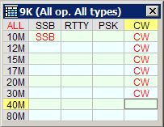

WCW_7

**Simple format**

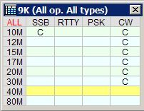

WCW_8

In the simple presentation only "W" and "C" indications are given and the only the band in use at the time is shown.

The text and background colors in the complex version of the table as shown above have the following meanings:

* + Red text - Band/Mode worked AND confirmed; and,
  + Blue text - Band/Mode worked but NOT confirmed

Once the full callsign of your QSO partner has been entered in the Loghbook Entry window, further information may be available if you have worked that station before and you have set the "Complex" mode of display.

The background colors in the individual Band/Mode combinations now indicate specific details for the particular callsign entered. In the example below, the red background indicates that 9K2ZZ has confirmed QSOs on 20M CW, 17M CW, 15M CW , and the light yellow background that he has been worked on 30M CW, 12M CW and 20M RTTY. The entry which is not highlighted indicates that the prefix 3D2 has been worked in this Band/Mode combination, but it was not with 3D2AG. The specific colors for these highlights may be selected form the Logger32 Setup menu, Highlight menu option.

The background colors and the display of the modes in the individual band/mode fields have two meanings:

* 1. The background colour indicates those band mode combinations recorded in the log as worked or confirmed for the particular callsign. This is NOT operator dependent.
  2. The infill of the mode shows the band/mode combinations worked for the PREFIX - by the current operator.

Additionally, the highlight markers in the Column/Row headers shows the current Band/Mode as determined from the radio frequency and the BandMmode table.

**Note**: It is advisable to perform a logbook recalculation occasionally to ensure that this table is correct.

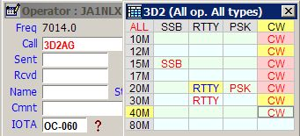

WCW_9

## 3.0 ADDITIONAL INFORMATION

Left clicking on any grid of the Worked/Confirmed Window will display the Additional Information dialog box, listing all log entries for the Band/Mode selected. For example, clicking on the 17M CW in WCW_9 above would display the following details from the logbook.

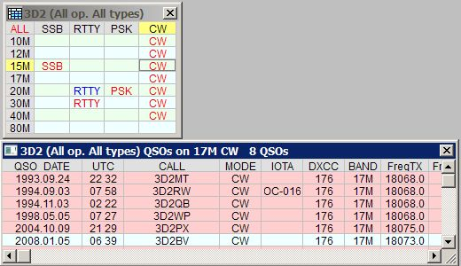

WCW_11

Observe that this action shows ALL the stations logged with the prefix 3D2.

Left-clicking on an empty grid in the Worked/Confirmed window will display a Mixed-Mode listing of all logbook entries for the selected band, regardless of mode. If you do not have an empty grid space in the Worked /Confirmed window, then the click on the empty gray rectangle in the upper left-hand corner of the table to achieve the same result, as below:

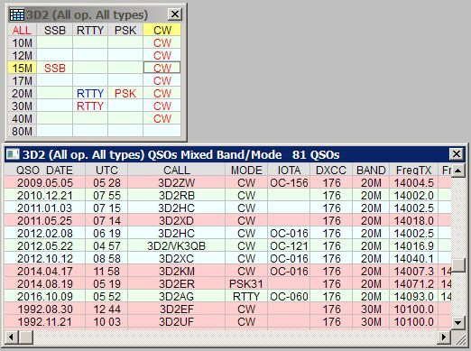

WCW_12

Both of the above generic window screenshots display the total number of QSOs in the title bar that meets the particular criteria. If the total number is less than the number of visible lines in the table, then this area in the title bar will be blank.

**Note**: Right-clicking on the Additional Information dialog box will display the Grid Layout Setup window, allowing you to customize the display in the same way as the Logbook Entry and Previous QSO windows. Left-clicking on any of the QSOs in this window will bring up the Previous QSO window and the Logbook Page window with appropriate data and will highlight the QSO in the Logbook.

## 4.0 Changing column’s order

The column’s order can be changed if you wish. Click “Column setup” in the menu.

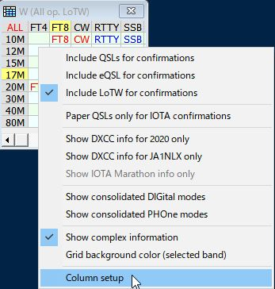

WCW_12A

Drag/drop any column to move the column and click “Apply”

before dragging column CW

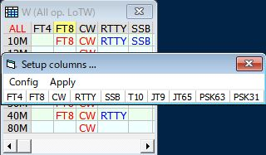

WCW_12B

after dropping column at most left

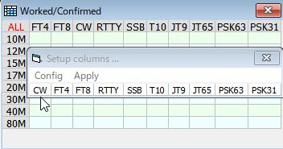

WCW_12C

after clicking “Apply”

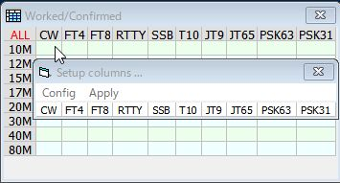

WCW_12D

Click “Config” in the menu bar to show another options.

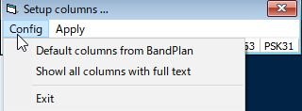

WCW_12E

**4.1 Default columns from BandPlan**

The columns are positioned in Column setup table referring to Setup Band/Mode table. Click “Apply” to be effective in Worked/Confirmed Window.

**4.2 Show all columns with full text**

All columns are displayed with proper width in Column setup table. Click “Apply” to be effective in Worked/Confirmed Window.

**4.3 Exit**

This close Column setup table.